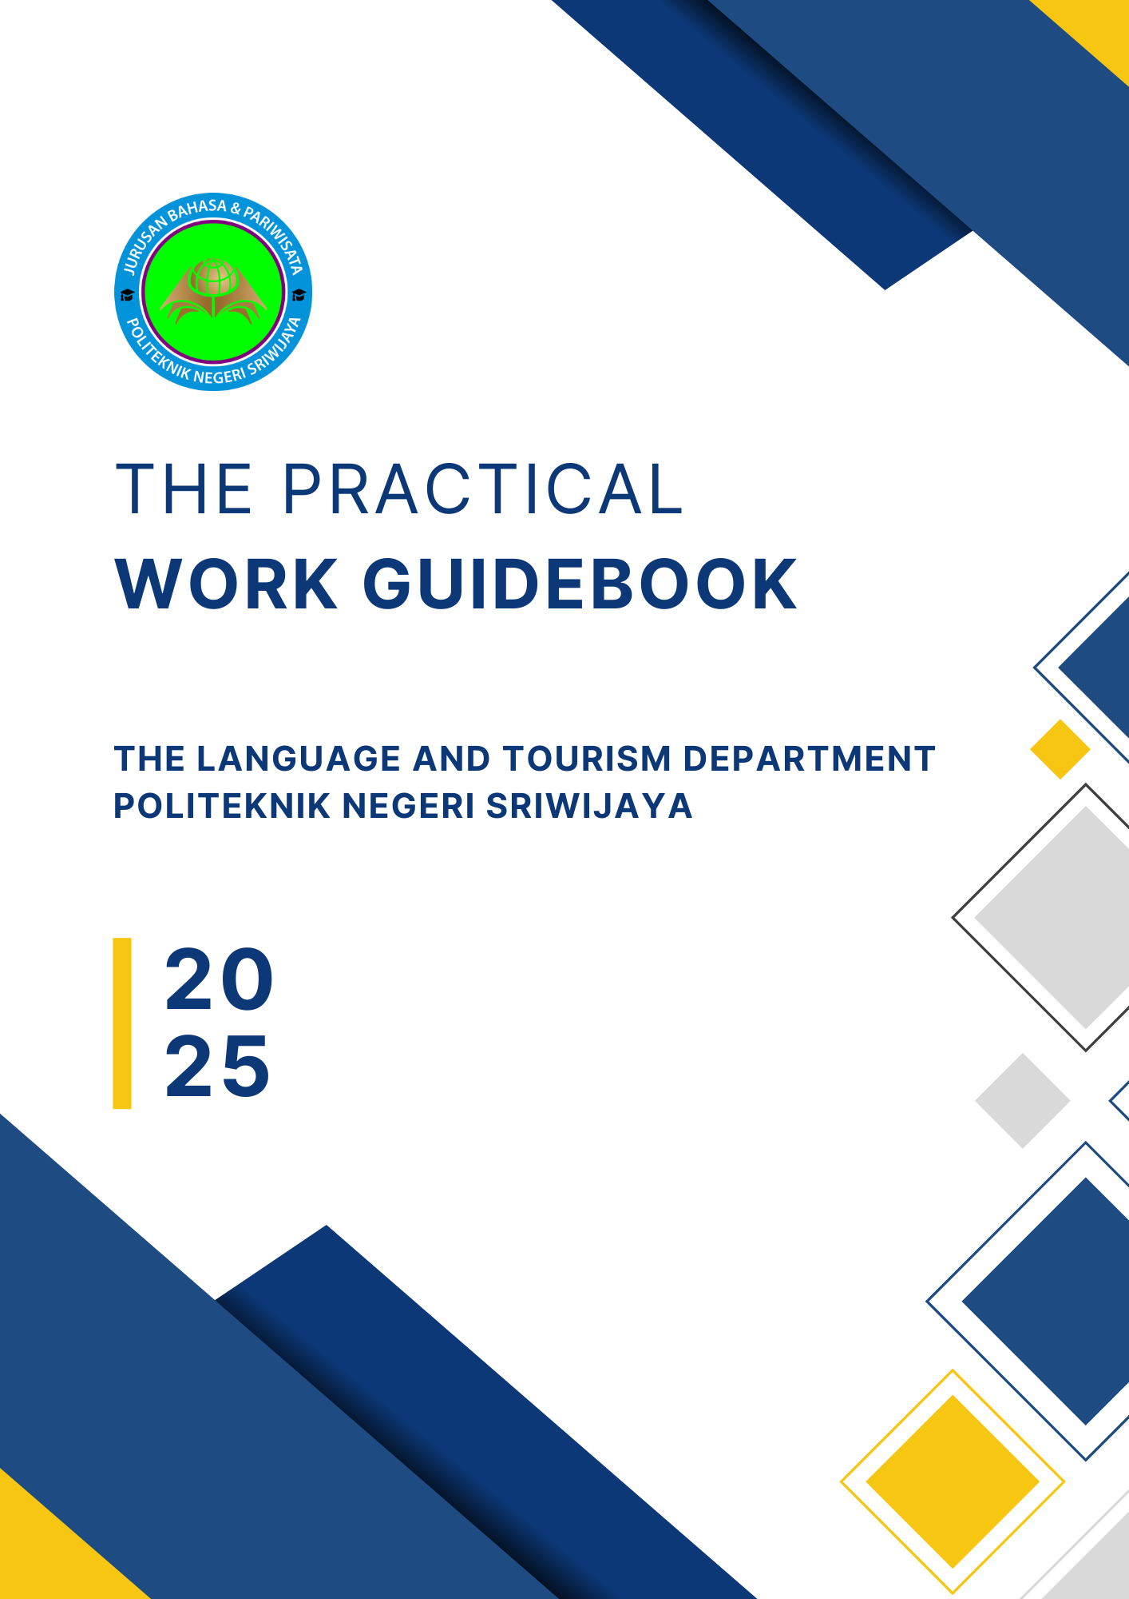

**PREFACE**

This Practical Work Guidebook has been published to provide an overview and information to students, teaching staff/supervising lecturers, and all parties requiring guidance on the implementation of practical work in the Language and Tourism Department of Politeknik Negeri Sriwijaya, Palembang.

Hopefully, this guidebook will serve as a reference, ensuring that everyone involved in the Practical Work program shares a common understanding of carrying out their duties and responsibilities with full accountability, following their respective roles and functions.

Naturally, the efforts made in compiling this guidebook are not without shortcomings, particularly in anticipating various possible challenges that may arise during its implementation. Therefore, the open-mindedness of all parties involved in the Practical Work program is greatly appreciated, as is constructive feedback for improving this guidebook.

Finally, we extend our deepest gratitude to all those who have contributed to the publication of this Practical Work Guidebook.

Palembang, February 2025

**TABLE OF CONTENTS**

Preface   
Table of Contents

I. Introduction

II. Objectives and Benefits

III. Preparation

IV. Implementation   
A. Practical Work (KP) Activities   
B. Supervisors

V. Reporting

VI. Writing Guidelines

VII. Evaluation   
A. Requirements   
B. Practical Work (KP) Assessment   
C. Seminar Implementation Procedures

VIII. Regulations for Daily Worker (DW) Implementation

**APPENDICES**

**I. Introduction**

Practical Work (KP) is a series of activities that encompass the understanding of theoretical and conceptual knowledge applied in professional settings. KP enhances students' perspectives, knowledge, and skills, enabling them to address academic and practical challenges in alignment with the theories they have acquired during their studies. The implementation of KP aims to ensure that students can comprehensively understand and effectively apply the knowledge within their field of study. Additionally, it allows students to gain insight into professional careers and workplace environments. As part of these objectives, the curriculum of Politeknik Negeri Sriwijaya includes Practical Work (KP) as a mandatory course. KP is a curricular activity that must be undertaken by every student upon completing the fourth semester (for Diploma programs) or the sixth semester (for Applied Bachelor programs). This practical work serves as an opportunity for students to gain hands-on experience, develop relevant skills, and acquire expertise by the competencies required in their respective study programs.

**2. Objectives and Benefits**

The Practical Work (KP) program aims to achieve the following objectives:

1. Provide students with the opportunity to apply the theoretical and conceptual knowledge acquired during their studies to real-world settings within an organization or company.
2. Enable students to gain practical experience relevant to their academic knowledge and acquired skills.
3. Allow students to analyze and evaluate the relationship between theoretical concepts and their practical implementation in a professional environment.
4. Assess students’ competencies in knowledge, skills, and their ability to apply these in practice, as well as their professional attitudes and workplace behavior.
5. Obtain feedback from industries regarding students’ competencies and industry needs to support curriculum development.

**3. Preparation**

1. Fourth-semester students are responsible for finding a placement for their Practical Work (KP).
2. Students must prepare a proposal to be submitted to the targeted industry, along with a cover letter approved by the Head of the Language and Tourism Department and forwarded to the Vice Director I.
3. The appointment of a supervisor is determined by the Vice Director I based on the recommendation of the Head of the Language and Tourism Department before the commencement of KP.
4. Students must consult with their assigned KP advisor before departing for their Practical Work Placement.

**5.** Initial orientation is conducted within each department by the Language and Tourism Department management.

**6.** A general orientation session is provided by the Management of Politeknik Negeri Sriwijaya.

**IV. Implementation**

**A. Practical Work Activities**

1. Practical Work (KP) is conducted after students have completed the fourth semester (for Diploma programs) or the sixth semester (for Applied Bachelor programs).
2. The duration of KP is three months.
3. Students must conduct a preliminary observation to identify a research topic. After the observation, they must report their findings to their academic supervisor for further consultation.
4. Students must develop a Practical Work (KP) activity plan in coordination with both their company supervisor and their academic supervisor from the polytechnic.
5. Students must comply with the regulations set by the company or organization where they undertake their KP.
6. Students are expected to maintain professional conduct and uphold the reputation of their alma mater.
7. Throughout the KP period, students must consult with both their company supervisor and their academic supervisor from Politeknik Negeri Sriwijaya.

**B. Advisors**

1. KP advisors are appointed based on recommendations from the Head of the Department and must hold a minimum academic rank of Junior Lecturer / III.a.
2. Each advisor is responsible for guiding a minimum of five (5) students.
3. Academic Advisors (PA) may assist students in consulting about the KP process and in securing KP placements.
4. The KP advisor will conduct monitoring of students' Practical Work activities.

### ****V. Reporting****

1. Upon completing the Practical Work (KP), students must report to their KP advisors.
2. The KP report must be submitted to the administrative staff of the Language and Tourism Department.
3. The KP report is prepared in groups or according to departmental regulations.
4. **Number of Reports:**

a. For seminar submission, the required copies are as follows:

(1) 3–5 copies for the examiners.

(2) 1 copy for the respective student.

(3) Additional copies for seminar participants as needed

b. The revised and approved KP report must be submitted as follows:

(1) 1 copy to the KP advisor

(2) 1 copy to the department library

(3) 1 copy to the central library

(4) 1 copy to the company, if required

(5) 1 original copy for the respective student

1. The cover color of the report is determined by the Language and Tourism Department.
2. Report Format:

a. The format for the KP report can be found in Appendix 1.

b. The format for the KP report cover can be found in Appendix 2.

c. The format for the approval page by the KP examiners can be found in Appendix 3.

d. The format for the approval page by the examiner can be found in Appendix 4.

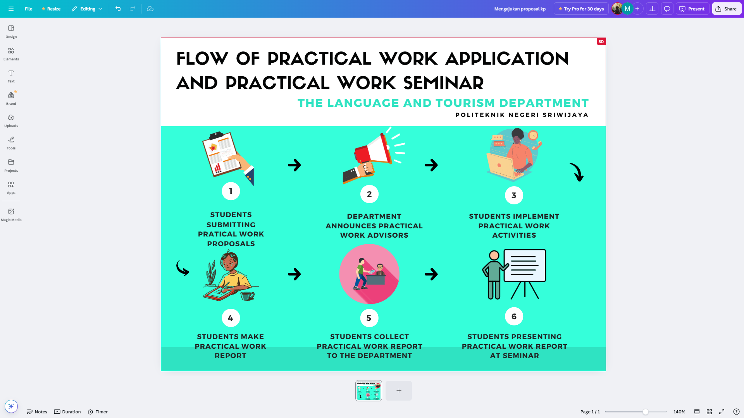

Figure 1. Flow of Practical Work Application and Practical Work Seminar

### ****VI. Writing Guidelines****

1. The KP report must be typed using **Times New Roman, size 12**, on **A4 paper (80 grams).**
2. Margins should be set as follows: **top 4 cm, bottom 3 cm, left 4 cm, and right 3 cm.**
3. **Line spacing:** 1.5.
4. The report must be written in **grammatically correct English.**
5. The KP report must contain a **minimum of 20 pages** (from Chapter I to Chapter V).
6. To support environmental sustainability (green campus), the KP Report shall be printed and reproduced on both sides

### ****VII. Evaluation****

#### ****A. Requirements for Participating in the KP Seminar:****

1. Submitting a report that has been approved by the KP advisor following the specified requirements.
2. Submitting the **assessment sheet and daily activity log** (Appendices 5 and 6).
3. Submitting a **Certificate of Completion** (official statement confirming the completion of KP) from the workplace.

#### ****B. Practical Work (KP) Assessment****

**■Assessment components include:**  
a. Evaluation of the **company supervisor** (Appendix 5).  
b. Evaluation of the **KP advisors** (Appendix 7).  
c. Evaluation of the **seminar presentation** (Appendix 8).

**■The Final Score is:**

**(Company Supervisor Score + KP Advisor Score + Seminar Score)**

**3**

### ****C. Seminar Implementation Procedures****

a. Seminar participants consist of: the examiners, seminar attendees, presenters, a moderator, and a note-taker.

b. Each presenter must individually present their paper in **English**, even if the KP activity was conducted in a group.

c. The seminar moderator and note-taker may be appointed from among the seminar participants or the examiners.

### ****VIII. Regulations for the Implementation of Daily Worker (DW)****

1. The duration of the Practical Work (KP) must be **three months**. Students who complete KP for less than three months are required to compensate with additional **Daily Worker (DW) hours** as follows:

**■For a two-month KP duration:** A minimum of **29 hours** (equivalent to one week of academic hours).

**■For a one-month KP duration:** A minimum of **58 hours** (equivalent to two weeks of academic hours).

1. The **Daily Worker (DW) activities** must not interfere with the student's academic schedule and should be conducted outside class hours or on weekends.
2. Students who fail to complete the required additional **Daily Worker (DW) hours** will receive a reduction in their final **KP score** based on the following criteria:

|  |  |  |  |
| --- | --- | --- | --- |
| **KP Duration** | **Additional DW Hours** | **Total Weight (KP + DW) %** | **KP Score Reduction** |
| 3 Months | 0 hours | 100% + 0% = 100% | 0% |
| 2 Months | Minimum 29 hours | 85% + 15% = 100% | <29 hours: -15% |
| 1 Month | Minimum 58 hours | 70% + 30% = 100% | <58 hours: -30% |

**Appendix 1** **(KP Report Proposal Format)**

**TABLE OF CONTENTS**

**Title** i

**Approval Page for Practical Work Proposal** ii

**Table of Contents** iii

**CHAPTER 1**  **INTRODUCTION**

1.1 Background 1

1.2 Objectives of Practical Work 2

1.3 Benefits of Practical Work 2

**CHAPTER II** **PRACTICAL WORK ACTIVITIES**

2.1 Location of Implementation 4

2.2 Duration of Implementation 4

2.3 Participants 4

2.4 Learning Outcomes 5

**CHAPTER III** **CONCLUSION** 9

**REFERENCES**

**Appendix 2 (KP Proposal Cover Format)**

**PRACTICAL WORK PROPOSAL**

**AT…………………………………………..**



This proposal is submitted as a requirement to commence Practical Work

at ……………………………………………

**By:**

* 1. …………………. (NPM)
  2. …………………. (NPM)
  3. …………………. (NPM)

**LANGUAGE AND TOURISM DEPARTMENT**

**POLITEKNIK NEGERI SRIWIJAYA**

**20..**

### ****Appendix 3 (Approval Page for KP Proposal)****

#### ****APPROVAL PAGE****

#### ****PRACTICAL WORK PROPOSAL****

**Practical Work Location :**

**Address of Practical Work Location :**

**Implementation Date :**

**Student Name(s) : 1.**  (NPM)

2. (NPM)

3 (NPM)

**Department :** Language and Tourism

**Study Program :** Diploma III in English

Palembang,

Acknowledged by, Kind Regards,

**Head of the Language and Tourism Department**  Representing Student

………………………………………….. ………………………..

NIP. …………………………….. NPM………………….

**Appendix 4 (KP Report Format)**

**TABLE OF CONTENTS**

2 space

**COVER i**

**APPROVAL SHEET ii**

**APPROVAL SHEET OF EXAMINERS iii**

**PREFACE iv**

**ACKNOWLEDGEMENT v**

**TABLE OF CONTENTS vi**

**LIST OF TABLES vii**

**LIST OF FIGURES viii**

**LIST OF APPENDICES ix**

1.5 space

Chapter must be bold

**CHAPTER I INTRODUCTION**

* 1. Background
  2. Formulation of Problems
  3. Purposes
  4. Benefits

1.5 space

**CHAPTER II GENERAL OVERVIEW/GENERAL DESCRIPTION OF THE COMPANY**

Chapter must be bold

2.1 Company History

2.2 Vision and Mission

2.3 Kind of Business

2.4 Organization Structure and Duties

2.5 The Working Process

2.6 Document used for Activities

1.5 space

Chapter must be bold

**CHAPTER III LITERATURE REVIEW**

3.1

3.2

1.5 space

**CHAPTER IV FINDINGS AND DISCUSSIONS**

Chapter must be bold

4.1 Findings

4.2 Discussions

1.5 space

**CHAPTER V CONCLUSIONS AND SUGGESTIONS**

Chapter must be bold

5.1 Conlusions

5.2 Suggestions

1.5 space

**REFERENCES**

**APPENDICES**

**LIST OF APPENDICES**

Appendix 1 KP Report Cover Format

Appendix 2 Approval Sheet

Appendix 3 Approval Sheet of Examiners

Appendix 4 Practical Work Application Letter

Appendix 5 Student Daily Activity Log for Practical Work

Appendix 6 Practical Work (KP) Student Evaluation Sheet from the Company/Industry /Institution

Appendix 7 Practical Work (KP) Report Supervision Report

Appendix 8 Evaluation of Practical Work (KP) Student Supervision

Appendix 9 Practical Work (KP) Report Seminar Recommendation

Appendix 10 Evaluation of Practical Work (KP) Seminar

Appendix 11 Recapitulation of Internship (KP) Seminar Scores

Appendix 12 Practical Work (KP) Report Revisions

Appendix 13 Implementation of Practical Work (KP) Report Revisions

**Appendix 1 (Practical Work Report Cover Format)**

**THE RESPONSIBILITES OF CUSTOMER SERVICES AT PT KERETA API INDONESIA (PERSERO) REGIONAL DIVISON III PALEMBANG**



This report is written to fulfill the requirement of practical work report

in the Language and Tourism Department

**By :**

**Balkis Susmiati 061730900653**

**Prili Aprilia 061730900663**

**Selvi Riaulina Lubis 061730900667**

**POLITEKNIK NEGERI SRIWIJAYA**

**PALEMBANG**

**2025**

**Appendix 2 (Approval Sheet)**

**APPROVAL SHEET**

**THE RESPONSIBILITES OF CUSTOMER SERVICES AT PT KERETA API INDONESIA (PERSERO) REGIONAL DIVISON III PALEMBANG**

**THE PRACTICAK WORK REPORT**

Palembang, ..............................

Acknowledged by Approved by

Head of Language and Tourism Department KP. Advisor

............................................... ............................................... NIP ........................................ NIP ................

**Appendix 3 (Approval Sheet of Examiners)**

**APPROVAL SHEET OF EXAMINERS**

**THE RESONSIBILITES OF CUSTOMER SERVICES AT PT KERETA API INDONESIA (PERSERO) REGIONAL DIVISON III PALEMBANG**

THE PRACTICAL WORK REPORT

**By :**

Balkis Susmiati 061730900653

Prili Aprilia 061730900663

Selvi Riaulina Lubis 061730900667

Approved by the examiners' committe Signatures

____________________________ ___________

NIP.

____________________________ ___________

NIP.

____________________________ ___________

NIP.

____________________________ ___________

NIP.

**POLITEKNIK NEGERI SRIWIJAYA**

**PALEMBANG**

**20…**

**Appendix 4 (Practical Work Application Letter)**

**Subject**: Application for Practical Work Palembang, ……………

**Attachment**: 1 (one) document

**Head of the Language and Tourism Department**  
Politeknik Negeri Sriwijaya

**Dear Mr…/Mrs…,**

Under the current curriculum at Politeknik Negeri Sriwijaya, we hereby plan to undertake Practical Work.

The students who will be participating in the Practical Work are as follows:

|  |  |  |  |
| --- | --- | --- | --- |
| **Number** | **Name** | **NPM** | **Class** |
| 1 |  |  |  |
| 2 |  |  |  |
| 3 |  |  |  |

About this matter, we kindly request the issuance of an Introduction Letter for Practical Work. The letter should be addressed to:

Company/Institution Name :

Recipient :

Address :

Implementation Period :

We sincerely appreciate your attention to this request.

Yours truly,

Representing student

…………………….

NPM……………….

**Appendix 5**

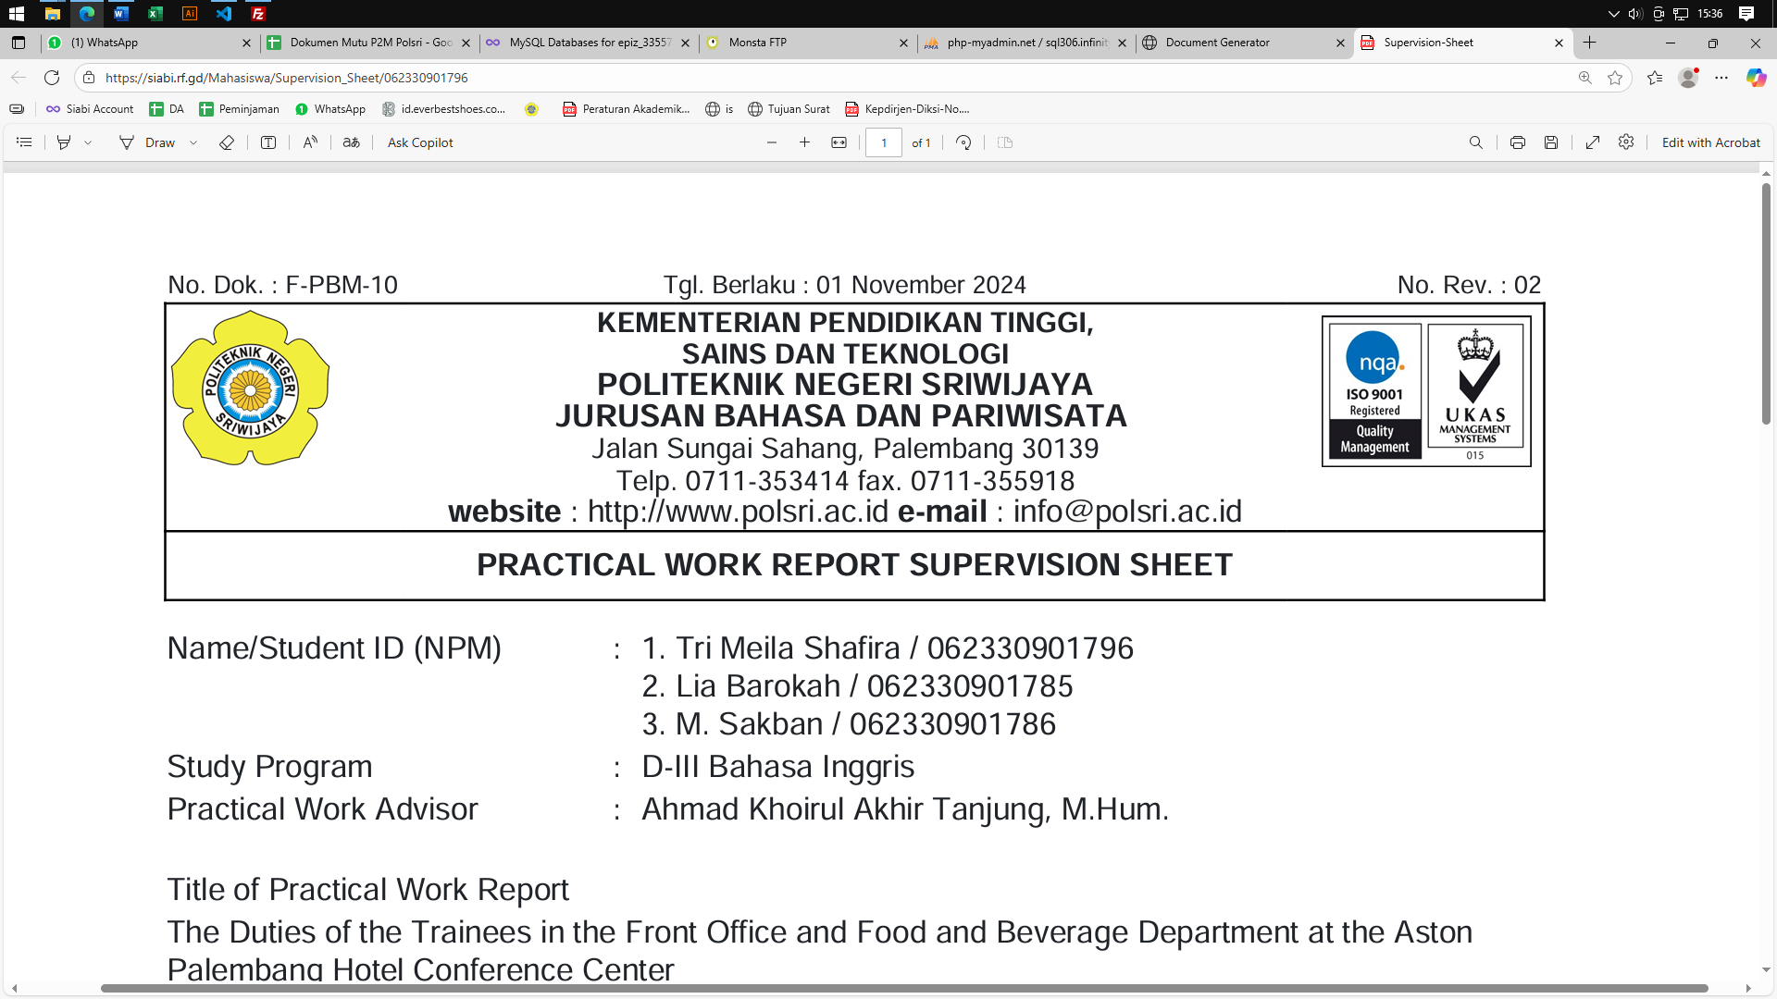

**STUDENT DAILY ACTIVITY LOG FOR PRACTICAL WORK**

**Student Name** : ……………………………………………………………… **Student ID (NPM)** : ……………………………………………………………… **Department/Study Program** : ……………………………………………………………… **Company/Institution Name** : ……………………………………………………………… **Unit/Division/Section** : ……………………………………………………………… **Company/Institution Address** :……………………………………………………………… **Practical Work Duration** : …………………… to ……………………………………...

|  |  |  |  |
| --- | --- | --- | --- |
| **Number** | **Date** | **Daily Activities** | **Company Supervisor’s Signature** |
|  |  |  |  |
|  |  |  |  |
|  |  |  |  |
|  |  |  |  |
|  |  |  |  |
|  |  |  |  |
|  |  |  |  |

**Note**: To be filled out by the student during Practical Work

Palembang,

Approved by, Student

Company/Institution Supervisor

………………………………… ………………………

No……………………………... NPM.

**Appendix 6**



**STUDENT PRACTICAL WORK ASSESSMENT FROM COMPANY/INDUSTRY/INSTITUTION**

**Student Name** : ……………………………………………………………… **Student ID (NPM)** : ……………………………………………………………… **Department/Study Program** : ……………………………………………………………… **Company/Institution Name** : ……………………………………………………………… **Unit/Division/Section** : ……………………………………………………………… **Company/Institution Address** :……………………………………………………………… **Practical Work Duration** : …………………… to ……………………………………...

|  |  |  |  |  |  |  |  |  |  |  |  |  |  |
| --- | --- | --- | --- | --- | --- | --- | --- | --- | --- | --- | --- | --- | --- |
| **Number** | **Assessment Parameters** | **Assessment Criteria** | | | | | | | | | | **Total Score**)** | |
| **Very Good** | | **Good** | | | **Fair** | | | **Poor** | |  | |
| 1 | Ethics | 10 | 9 | 8 | 7 | 6 | | 5 | 4 | | 3 |  | |
| 2 | Discipline | 10 | 9 | 8 | 7 | 6 | | 5 | 4 | | 3 |  | |
| 3 | Self-confidence | 10 | 9 | 8 | 7 | 6 | | 5 | 4 | | 3 |  | |
| 4 | Cooperation | 10 | 9 | 8 | 7 | 6 | | 5 | 4 | | 3 |  | |
| 5 | Motivation | 10 | 9 | 8 | 7 | 6 | | 5 | 4 | | 3 |  | |
| 6 | Working Initiative | 10 | 9 | 8 | 7 | 6 | | 5 | 4 | | 3 |  | |
| 7 | Loyalty | 10 | 9 | 8 | 7 | 6 | | 5 | 4 | | 3 |  | |
| 8 | Work Responsibility | 10 | 9 | 8 | 7 | 6 | | 5 | 4 | | 3 |  | |
| 9 | Understanding and Ability in Performing and Completing Tasks | 10 | 9 | 8 | 7 | 6 | | 5 | 4 | | 3 |  | |
| 10 | Occupational Health and Safety | 10 | 9 | 8 | 7 | 6 | | 5 | 4 | | 3 |  | |
| Total Score | | | | | | | | | | | | |  | |

*) Circle the appropriate rating number.  
**) Write down the score according to the rating number.

………………….,……………………….

Acknowledged by, Company/Institution Supervisor

Company/Institution Leader

…………………………….. ……………………………..

No. ………………………… No. …………………………

**Note:** Please send this assessment form to Politeknik Negeri Sriwijaya as soon as the student has completed the Practical Work.

**Appendix 7**



**PRACTICAL WORK REPORT SUPERVISION SHEET**

Name/Student ID (NPM) : 1. XXXXXXXX/062020

2. XXXXXXXX/062022

3. XXXXXXXX/062023

Study Program : …………………………………………………………..

Practical Work Advisor : …………………………………………………………..

Title of Practical Work Report

…………………………………………………………………………………………………………………………………………………………………………………………………………………………………………………………………………………………………………………………………………………………………………………………………………………..………………………………………………..

**Advisor’s Notes:**

|  |  |  |  |
| --- | --- | --- | --- |
| **Number** | **Day/Date** | **Topic** | **Signature** |
| 1 |  |  |  |
| 2 |  |  |  |
| 3 |  |  |  |
| 4 |  |  |  |
| 5 |  |  |  |
| 6 |  |  |  |
| 7 |  |  |  |
| 8 |  |  |  |
| 9 |  |  |  |
| 10 |  |  |  |
| 11 |  |  |  |
| 12 |  |  |  |
| 13 |  |  |  |
| 14 |  |  |  |
| 15 |  |  |  |
| 16 |  |  |  |
| 17 |  |  |  |
| 18 |  |  |  |
| 19 |  |  |  |
| 20 |  |  |  |

**Advisor’s Notes**

|  |
| --- |
| ……………………………………………………………………………………………………………………………………………………………………………………………………………………………………………………………………………………………………………………………………………………………………………………………………………………………………………………………………………………………………………………………………………………………………………………………………………………………………………………………………………………………………………………………………………………………………………………………………………………………………………………………………………………………………………………………………………………………………………………………………………………………………………………………………………………………… |
| ……………………………………………………………………………………………………………………………………………………………………………………………………………………………………………………………………………………………………………………………………………………………………………………………………………………………………………………………………………………………………………………………………………………………………………………………………………………………………………………………………………………………………………………………………………………………………………………………………………………………………………………………………………………………………………………………………………………………………………………………………………………………………………………………………………………………… |
| ……………………………………………………………………………………………………………………………………………………………………………………………………………………………………………………………………………………………………………………………………………………………………………………………………………………………………………………………………………………………………………………………………………………………………………………………………………………………………………………………………………………………………………………………………………………………………………………………………………………………………………………………………………………………………………………………………………………………………………………………………………………………………………………………………………………………… |

Palembang, …………..…………

The Head of the Language and Tourism Department,

……….………………………….……

NIP. …………………………………

**Appendix 9**



**SEMINAR RECOMMENDATION FOR PRACTICAL WORK REPORT**

The Practical Work (KP) advisor provides a recommendation for:

**Name** : ……………………………………………………………………… **Student ID (NPM)** : ……………………………………………………………………… **Department** : ……………………………………………………………………… **Report Title** : ………………………………………………………………………

The aforementioned student has met the requirements and is eligible to participate in the Practical Work (KP) Report Seminar in the Academic Year …

Palembang, …………………………

KP. Advisor,

…………………………………….

NIP. ………………………………..

**Appendix 12**



**REVISION OF PRACTICAL WORK REPORT**

**Room :** ………………………………………………………………

**Examiner** : ……………………………………………………………… **Name/Student ID (NPM)** : ……………………………………………………………… **Department** : ……………………………………………………………… **Report Title** : ………………………………………………………………

|  |  |  |
| --- | --- | --- |
| **Number** | **Revision Description** | **Signature** |
|  |  |  |

Palembang, …………………………

Examiner,

…………………………………….

NIP. ………………………………..

**Appendix 13**



**IMPLEMENTATION OF PRACTICAL WORK REPORT REVISION**

The following student(s):

Name/Student ID (NPM) : 1. XXXXXXXX/062020

2. XXXXXXXX/062022

3. XXXXXXXX/062023

Department : …………………………………………………………..

Title of Practical Work Report : …………………………………………………………..

Has made revisions to the Internship Report (KP) presented in the seminar on ……………. Date ……….. Month ……………… Year ……………..

The implementation of the revisions to the Practical Work Report (KP) has been approved by the Examiners who provided the revisions.

|  |  |  |  |  |
| --- | --- | --- | --- | --- |
| **Number** | **Comment** | **Examiner*)** | **Date** | **Signature** |
|  |  |  |  |  |
|  |  |  |  |  |
|  |  |  |  |  |
|  |  |  |  |  |
|  |  |  |  |  |

Palembang, …………………………

Chief Examiner**),

…………………………………….

NIP. ………………………………..

Notes:  
*) The examiner who provides revisions during the KP report seminar.  
**) The evaluating lecturer assigned as the Chief Examiner during the KP report seminar.  
This revision implementation sheet must be attached to the Practical Work (KP) Report.