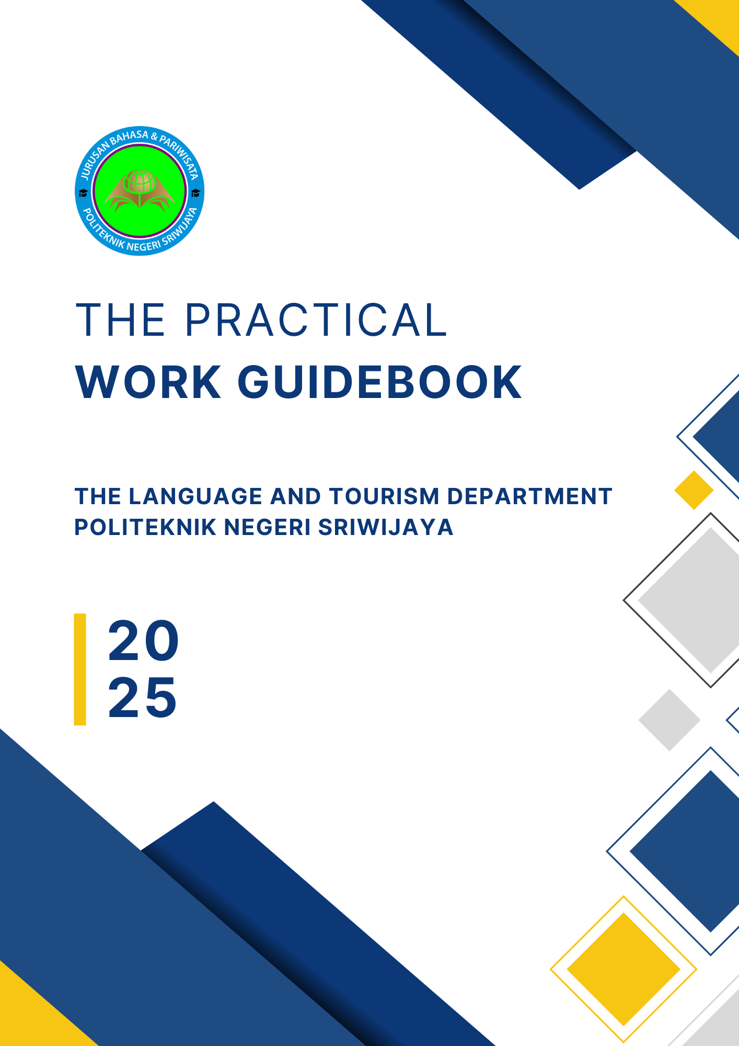


PREFACE
This Practical Work Guidebook has been published to provide an overview and information to students, teaching staff/supervising lecturers, and all parties requiring guidance on the implementation of practical work in the Language and Tourism Department of Politeknik Negeri Sriwijaya, Palembang.
Hopefully, this guidebook will serve as a reference, ensuring that everyone involved in the Practical Work program shares a common understanding of carrying out their duties and responsibilities with full accountability, following their respective roles and functions.
Naturally, the efforts made in compiling this guidebook are not without shortcomings, particularly in anticipating various possible challenges that may arise during its implementation. Therefore, the open-mindedness of all parties involved in the Practical Work program is greatly appreciated, as is constructive feedback for improving this guidebook.
Finally, we extend our deepest gratitude to all those who have contributed to the publication of this Practical Work Guidebook.

Palembang, February 2025

TABLE OF CONTENTS
Preface
Table of Contents
I. Introduction
II. Objectives and Benefits
III. Preparation
IV. Implementation
A. Practical Work (KP) Activities
B. Supervisors
V. Reporting
VI. Writing Guidelines
VII. Evaluation
A. Requirements
B. Practical Work (KP) Assessment
C. Seminar Implementation Procedures
VIII. Regulations for Daily Worker (DW) Implementation
APPENDICES

I. Introduction
Practical Work (KP) is a series of activities that encompass the understanding of theoretical and conceptual knowledge applied in professional settings. KP enhances students' perspectives, knowledge, and skills, enabling them to address academic and practical challenges in alignment with the theories they have acquired during their studies. The implementation of KP aims to ensure that students can comprehensively understand and effectively apply the knowledge within their field of study. Additionally, it allows students to gain insight into professional careers and workplace environments. As part of these objectives, the curriculum of Politeknik Negeri Sriwijaya includes Practical Work (KP) as a mandatory course. KP is a curricular activity that must be undertaken by every student upon completing the fourth semester (for Diploma programs) or the sixth semester (for Applied Bachelor programs). This practical work serves as an opportunity for students to gain hands-on experience, develop relevant skills, and acquire expertise by the competencies required in their respective study programs.
2. Objectives and Benefits
The Practical Work (KP) program aims to achieve the following objectives:
- Provide students with the opportunity to apply the theoretical and conceptual knowledge acquired during their studies to real-world settings within an organization or company.
- Enable students to gain practical experience relevant to their academic knowledge and acquired skills.
- Allow students to analyze and evaluate the relationship between theoretical concepts and their practical implementation in a professional environment.
- Assess students’ competencies in knowledge, skills, and their ability to apply these in practice, as well as their professional attitudes and workplace behavior.
- Obtain feedback from industries regarding students’ competencies and industry needs to support curriculum development.
3. Preparation
- Fourth-semester students are responsible for finding a placement for their Practical Work (KP).
- Students must prepare a proposal to be submitted to the targeted industry, along with a cover letter approved by the Head of the Language and Tourism Department and forwarded to the Vice Director I.
- The appointment of a supervisor is determined by the Vice Director I based on the recommendation of the Head of the Language and Tourism Department before the commencement of KP.
- Students must consult with their assigned KP advisor before departing for their Practical Work Placement.
5. Initial orientation is conducted within each department by the Language and Tourism Department management.
6. A general orientation session is provided by the Management of Politeknik Negeri Sriwijaya.

IV. Implementation

A. Practical Work Activities
- Practical Work (KP) is conducted after students have completed the fourth semester (for Diploma programs) or the sixth semester (for Applied Bachelor programs).
- The duration of KP is three months.
- Students must conduct a preliminary observation to identify a research topic. After the observation, they must report their findings to their academic supervisor for further consultation.
- Students must develop a Practical Work (KP) activity plan in coordination with both their company supervisor and their academic supervisor from the polytechnic.
- Students must comply with the regulations set by the company or organization where they undertake their KP.
- Students are expected to maintain professional conduct and uphold the reputation of their alma mater.
- Throughout the KP period, students must consult with both their company supervisor and their academic supervisor from Politeknik Negeri Sriwijaya.

B. Advisors
- KP advisors are appointed based on recommendations from the Head of the Department and must hold a minimum academic rank of Junior Lecturer / III.a.
- Each advisor is responsible for guiding a minimum of five (5) students.
- Academic Advisors (PA) may assist students in consulting about the KP process and in securing KP placements.
- The KP advisor will conduct monitoring of students' Practical Work activities.

V. Reporting
- Upon completing the Practical Work (KP), students must report to their KP advisors.
- The KP report must be submitted to the administrative staff of the Language and Tourism Department.
- The KP report is prepared in groups or according to departmental regulations.
- Number of Reports:
a. For seminar submission, the required copies are as follows:
(1) 3–5 copies for the examiners.
(2) 1 copy for the respective student.
(3) Additional copies for seminar participants as needed
b. The revised and approved KP report must be submitted as follows:
(1) 1 copy to the KP advisor
(2) 1 copy to the department library
(3) 1 copy to the central library
(4) 1 copy to the company, if required
(5) 1 original copy for the respective student
- The cover color of the report is determined by the Language and Tourism Department.
- Report Format:
a. The format for the KP report can be found in Appendix 1.
b. The format for the KP report cover can be found in Appendix 2.
c. The format for the approval page by the KP examiners can be found in Appendix 3.
d. The format for the approval page by the examiner can be found in Appendix 4.
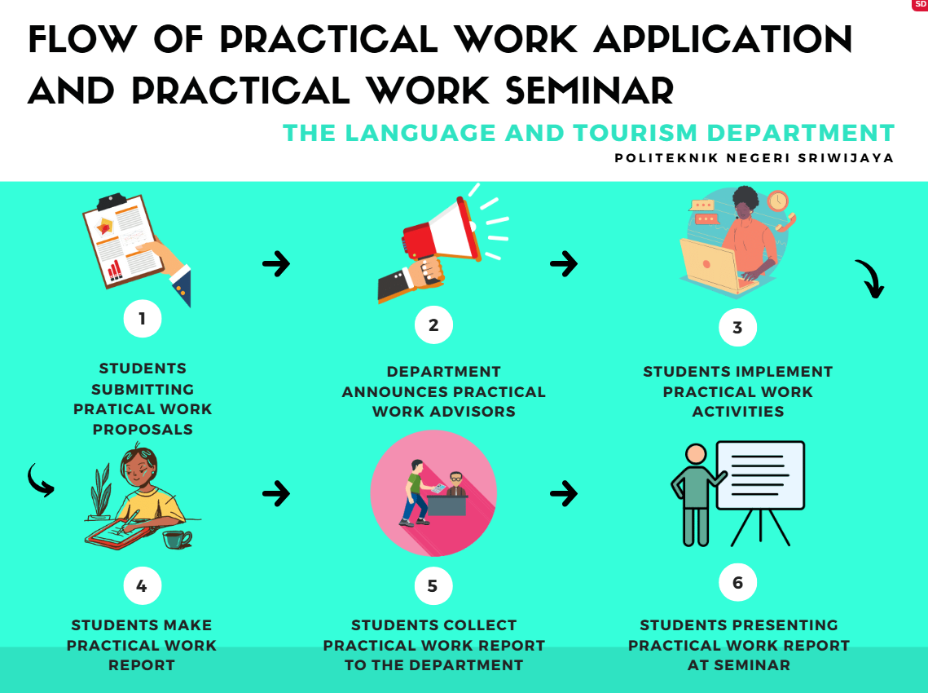
Figure 1. Flow of Practical Work Application and Practical Work Seminar

VI. Writing Guidelines
- The KP report must be typed using Times New Roman, size 12, on A4 paper (80 grams).
- Margins should be set as follows: top 4 cm, bottom 3 cm, left 4 cm, and right 3 cm.
- Line spacing: 1.5.
- The report must be written in grammatically correct English.
- The KP report must contain a minimum of 20 pages (from Chapter I to Chapter V).
- To support environmental sustainability (green campus), the KP Report shall be printed and reproduced on both sides

VII. Evaluation

A. Requirements for Participating in the KP Seminar:
- Submitting a report that has been approved by the KP advisor following the specified requirements.
- Submitting the assessment sheet and daily activity log (Appendices 5 and 6).
- Submitting a Certificate of Completion (official statement confirming the completion of KP) from the workplace.

B. Practical Work (KP) Assessment
■Assessment components include:
a. Evaluation of the company supervisor (Appendix 5).
b. Evaluation of the KP advisors (Appendix 7).
c. Evaluation of the seminar presentation (Appendix 8).
■The Final Score is:
(Company Supervisor Score + KP Advisor Score + Seminar Score)
3

C. Seminar Implementation Procedures
a. Seminar participants consist of: the examiners, seminar attendees, presenters, a moderator, and a note-taker.
b. Each presenter must individually present their paper in English, even if the KP activity was conducted in a group.
c. The seminar moderator and note-taker may be appointed from among the seminar participants or the examiners.

VIII. Regulations for the Implementation of Daily Worker (DW)
- The duration of the Practical Work (KP) must be three months. Students who complete KP for less than three months are required to compensate with additional Daily Worker (DW) hours as follows:
■For a two-month KP duration: A minimum of 29 hours (equivalent to one week of academic hours).
■For a one-month KP duration: A minimum of 58 hours (equivalent to two weeks of academic hours).
- The Daily Worker (DW) activities must not interfere with the student's academic schedule and should be conducted outside class hours or on weekends.
- Students who fail to complete the required additional Daily Worker (DW) hours will receive a reduction in their final KP score based on the following criteria:

KP Duration | Additional DW Hours | Total Weight (KP + DW) % | KP Score Reduction
3 Months | 0 hours | 100% + 0% = 100% | 0%
2 Months | Minimum 29 hours | 85% + 15% = 100% | <29 hours: -15%
1 Month | Minimum 58 hours | 70% + 30% = 100% | <58 hours: -30%

VIII. Tables
- Tables must be created with a table title written above the table.
- The table title shall be in 11-point font, left, in italic, and should indicate the chapter to which the table belongs (e.g., Table 1.x for a table in Chapter 1, Table 2.x for a table in Chapter 2, etc.).
- The text within tables shall be single-spaced and set in 10-point font.
- Tables should include only top and bottom borders, with no side borders.
- The text in tables should be left-aligned with a one-space gap.
- Table captions should be differentiated by chapter-for example, Table 1.x for tables in Chapter 1, Table 2.x for those in Chapter 2, and so on.
- The source of the table should be written at the end of the table in 10 point font. The word ‘source:’ is written in italic, while the content is not.

example:

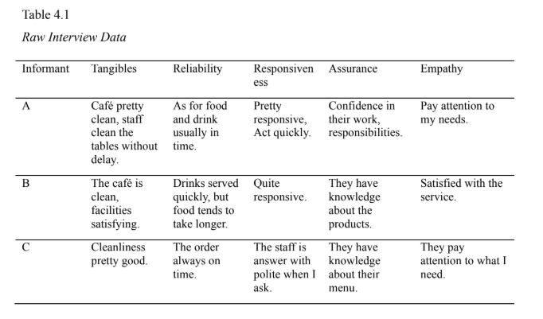
Source: Private Document

IX. Figures
- The figure is created with a caption written above the figure.
- The caption is positioned to the left above the figure, written in font size 11 and in italic.
- The source of the figure is written below the figure in font size 10.
- The figure description is written using font size 11.
- The labeling of figures is differentiated by chapter. For example, Figure 1.x refers to the x-th figure in the first chapter, Figure 2.x refers to the x-th figure in the second chapter, and so on.

example:

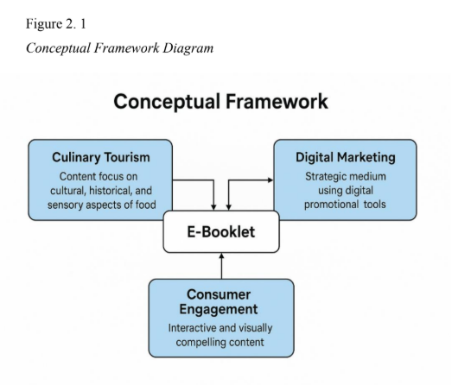
Source: Private Document

TABLE OF CONTENTS
2 space

COVER i
APPROVAL SHEET ii
APPROVAL SHEET OF EXAMINERS iii
PREFACE iv
ACKNOWLEDGEMENT v
TABLE OF CONTENTS vi
LIST OF TABLES vii
LIST OF FIGURES viii
LIST OF APPENDICES ix
1.5 space
Chapter must be bold
CHAPTER I INTRODUCTION
  - Background
  - Formulation of Problems
  - Purposes
  - Benefits
1.5 space
CHAPTER II GENERAL OVERVIEW/GENERAL DESCRIPTION OF THE COMPANY
Chapter must be bold
2.1 Company History
2.2 Vision and Mission
2.3 Kind of Business
2.4 Organization Structure and Duties
2.5 The Working Process
2.6 Document used for Activities
1.5 space
Chapter must be bold
CHAPTER III LITERATURE REVIEW
3.1
3.2
1.5 space

CHAPTER IV FINDINGS AND DISCUSSIONS
Chapter must be bold
4.1 Findings
4.2 Discussions
1.5 space

CHAPTER V CONCLUSIONS AND SUGGESTIONS
Chapter must be bold
5.1 Conlusions
5.2 Suggestions
1.5 space

REFERENCES
APPENDICES


APPENDICES

